Management Instruction for Tooling Periodic Inspection for COMAC Program

- Scope

This management instruction specifies regulations of tooling periodic inspection.
This management instruction is applicable to COMAC program production.
This management instruction is developed in accordance with the requirements GLC14070305 and SR0006.

- Reference documents

SR0006 Regulations of Tooling Design, Manufacturing, Acceptance and Management
GLC14070305 Management Procedure for Tooling Periodic Inspection
GLC231008 Management Procedure for Quality Records

- Form

3.1 Prescribed Form
None
3.2 Referenced Form
SAMC 04-58 Tooling Periodic Inspection Plan (Appendix A)
SAMC 04-58.1 Tooling Periodic Inspection Plan Continuation Sheet (Appendix B)
SAMC 05-50 COMAC Shared Tooling Inspection Signage (Appendix C)

- Terms and Definitions
None

- Regulations

5.1 The technician in Tooling Office prepares and sets the periodic inspection tooling catalog with reference to "COMAC Control Tooling Project Catalog".
5.2
For the tooling required for periodic inspection in the COMAC Control Tooling program, the technician in Tooling Office will submit the tooling periodic inspection plan (SAMC 04-58(S)) to the COMAC representative for approval after the design review is passed. The contents of the periodic inspection plan shall at least include the elements and methods of periodic inspection and the tools used in the process of periodic inspection. Any subsequent changes to the tooling periodic inspection plan shall be resubmitted to COMAC representatives for approval and the tooling periodic inspection work shall be carried out in accordance with the periodic inspection plan approved by COMAC representatives.
5.3 Tooling Periodic Inspection Requirements at The Development and Batch Stage
5.3.1
When the following situations occur, it is necessary to check the periodic inspection tooling in the COMAC control tooling project.
a) Development stage of the assembly tooling before each unit starts.
b) If the start date of the first assembly is more than 30 days after the delivery date of the tooling (including new production, major change of repair, and change of installation location).
c) Restart when the deactivation date exceeds the periodic inspection period.
5.3.2 For the periodic inspection tooling with product inspection function, the maximum periodic inspection period shall not exceed 18 months.
5.4 Into the batch production stage, type II tooling, bearing a certain load of the product, lifting support joints and jacks, tooling with product inspection function and inspection samples (only used for product inspection, but not for manufacturing other tooling or directly processed products) must be periodic inspected and records of each periodic inspection should be kept. The maximum periodic inspection period of the tooling shall not exceed 24 months.
5.5 The accuracy of type II tooling may be affected by an earthquake of magnitude 5.0 or greater occurring within a radius of 80 km. The tooling datum must be immediately measured per periodical tooling inspection process, the nonconformance tooling must be reworked and re-measured, tooling can be used until qualified. If top 20% of tooling are qualified, the Tooling Office organize the department that perform measurement to apply for approval from a representative appointed by COMAC for exemption from inspection of the other tooling.
5.6 For inter-factory shared tooling that are periodically inspected according to "date" cycle, the inspector in Quality Engineering Office of Tooling User shall ensure if tooling are within validate date via checking tooling tag and submit COMAC quality representative for confirmation before using tooling . The inter-factory shared tooling that exceed validate date must not be used.
5.7 Usually COMAC shall be responsible for the inspection of inter-factory shared tooling. If SACC is responsible for the inspection of inter-factory shared tooling, the quality representative of COMAC shall participate in the acceptance, the inspector in Quality Engineering Office of Tooling User shall coordinate with COMAC to fill in relevant tooling periodical inspection information. For inter-factory shared tooling that are periodically inspected according to "ship set" cycle, fill in the specific unit information used by the tooling on the periodic inspection (SAMC 05-50). The content and seal should be correct, complete, clear and not easy to erase. For signs made of metal or plastic material, steel marked should be used. The inspector in Quality Engineering Office of Tooling User shall verify that the above information is correct, complete and clear and submit it to COMAC quality representative for confirmation before using tooling.

6 Standard Legend Description
None

7 Record Control

7.1 Relevant records should be filled and maintained in accordance with procedure GLC231008 requirements.
7.2 The tooling periodic inspection records should be kept for at least 10 years.

附录A
(Appendix A)
（资料性附录）
(Informative Appendix)
SAMC 04-58（2020-03）
工装定期检查计划
Periodic Tooling Inspection Plan
共 页 第 页 Page Of
机 型  Model | （1） | 计划下发依据  Basis for issuing the plan | （6）
检查周期
Period of inspection
工装图号  Drawing No. of tooling | （2） | □ 架次周期 Period of ship sets （7）  限用 架份  Limited used for amounts of aircrafts
工装名称  Name of tooling | （3）
编制/日期  Compilation/date | （4） | □ 日期周期 Period of date （8）  周  Weeks
校对/日期  Proof/date | （5）
检验/完工日期  Inspection/completion date | （9）

附录B
(Appendix B)
（资料性附录）
(Informative Appendix)
SAMC 04-58.1（2020-03）
工装定期检查计划续页
Periodic Tooling Inspection Plan Sequel Page
工装图号: （10）  Drawing No. of tooling |  |  | 编制/日期: （11）  Compilation/date | 共 页 第 页  Page of
序号  Serial No. | 工装图  页次/图区  Page/area of tooling drawing | 零件号  Part number | 检验内容  Content of inspection | 测量工具  Measure Tools | 记录  Record | 操作者  Operator | 检验印  Inspection Seal
（12） | （13） | （14） | （15） | （16） | （17） | （18） | （19）

填写说明 Instruction for Filling

（1）：工艺装备室技术员填入适用的机型。
The technician in Tooling Room fills in the appropriate model.
（2）：工艺装备室技术员填入要检查的工装图号。
The technician in Tooling Room fills in the drawing number of tooling to be checked.
（3）：工艺装备室技术员填入要检查的工装名称。
The technician in Tooling Room fills in the name of tooling to be checked.
（4）：编制人员签字并注明日期。
Signed and noted date by the preparer.
（5）：校对人员签字并注明日期。
Signed and noted date by the proofreader.
（6）：工艺装备室技术员填写计划下发的依据
The technician in Tooling Room fills out the distribution basis of the plan.
（7）：工艺装备室技术员填写工装定期检查架份数。
The technician in Tooling Room fills in the certain amounts of aircrafts to be periodic checked.
（8）：工艺装备室技术员在工装日期周期检查阶段填写检查周期。
The technician in Tooling Room fills in the inspection period during the tooling date cycle inspection phase.
（9）：工装检验人员盖检验印章并注明检验日期。
The tooling inspector seals the inspection and note date of inspection completion.
（10）：工艺装备室技术员填入要检查的工装图号。
The technician in Tooling Room fills in the drawing number of tooling to be checked.
（11）：编制人员签字并注明日期。。
Signed and noted date by the preparer.
（12）：工艺装备室技术员按需填入顺序号，即“1、2、3……”
The technician in Tooling Room fills in the serial number as required, i.e.“1、2、3……”.
（13）：工艺装备室技术员按需填写工装图纸中检查部位的页次、图区。
The technician in Tooling Room fills in the page number and area of the inspection parts in the tooling drawing as required.
（14）：工艺装备室技术员填写需要检验的内容。
The technician in Tooling Room fills in the contents that need to be inspected.
（15）：工艺装备室技术员按需填写工装零件号。
The technician in Tooling Room fills in the tooling part number as required.
（16）：工艺装备室技术员按需填入测量时所需工具、设备。
The technician in Tooling Room fills in the necessary tools and equipments for measurement.
（17）：工艺装备室技术员按需填入检查后的记录形式、内容等。
The technician in Tooling Room fills in the record situation, contents, etc. after inspection as required.
（18）：工装定检操作者盖章或签字（当操作者未参与操作过程时无需盖章）。
Operator seal or signature.(No need to seal or signature while unrelated)
（19）：工装定检检验人员盖章。
Inspector seal.
注1：工艺装备室技术员可按实际编制计划的情况添加页数。
Note 1: Page can be added as the actual plan is prepared by the technician in Tooling Room.
注2：工艺装备室技术员在每页上部（除封面）左侧应写明图号，以免散开后不能分辨所检查的工装。
Note 2: At the top of each page(except the cover),the left side should be marked with the drawing number by the technician in Tooling Room, so as to avoid being unable to distinguish the checked tooling after the spread.
注3：工艺装备室技术员在每页上部右侧应写明共几页第几页。
Note 3: The top right side of each page should contain page of by the technician in Tooling Room

附录C
(Appendix C)
（资料性附录）
(Informative Appendix)
商飞共用工装定检标牌
COMAC Shared Tooling Inspection Signage
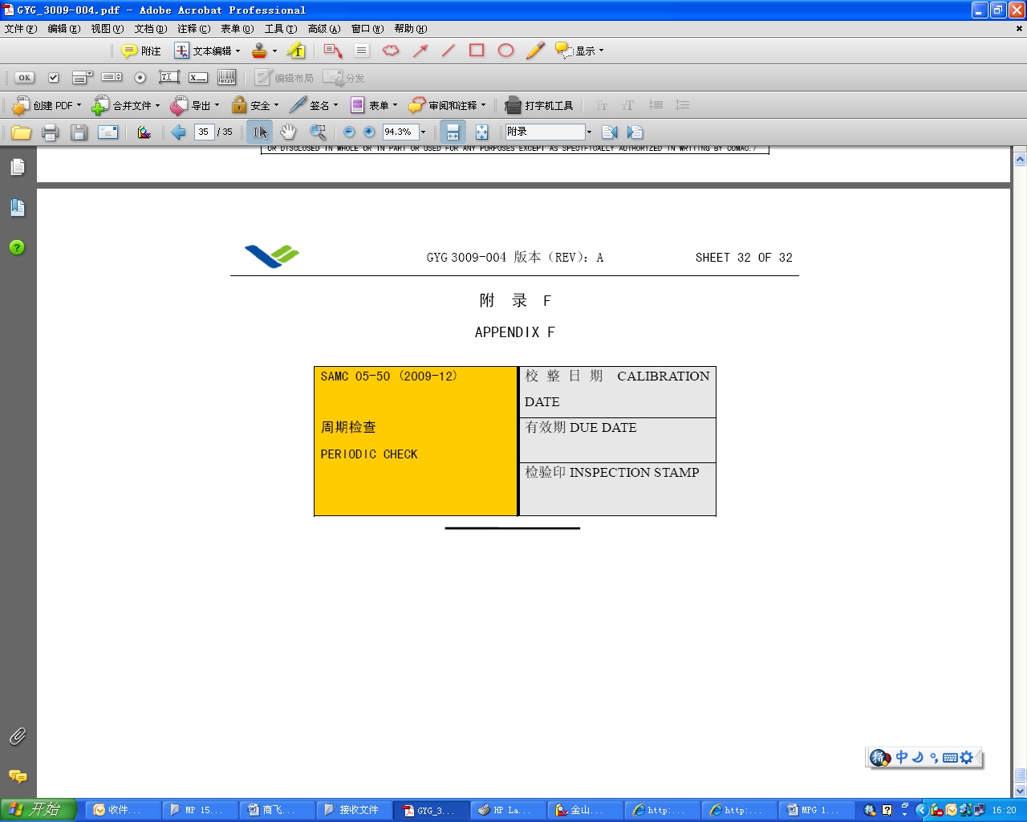
（1）

（2）
（3）

填写说明 Instruction for Filling

本表随工装流转
(1) ：工装定检测量人员填写工装定检的完成日期。
Periodical tooling inspection measurement operator fills in qualified periodical tooling inspection date.
(2) ：工装定检测量人员填写下次实施工装定检的日期，对于按架份定检的工装填写有效架份。
Periodical tooling inspection measurement operator fills next periodical tooling inspection date, or effective ship sets for periodical tooling inspection per ship sets .
(3)：工装定检检验人员盖检验印章。
Inspector’s stamp for periodical tooling inspection.

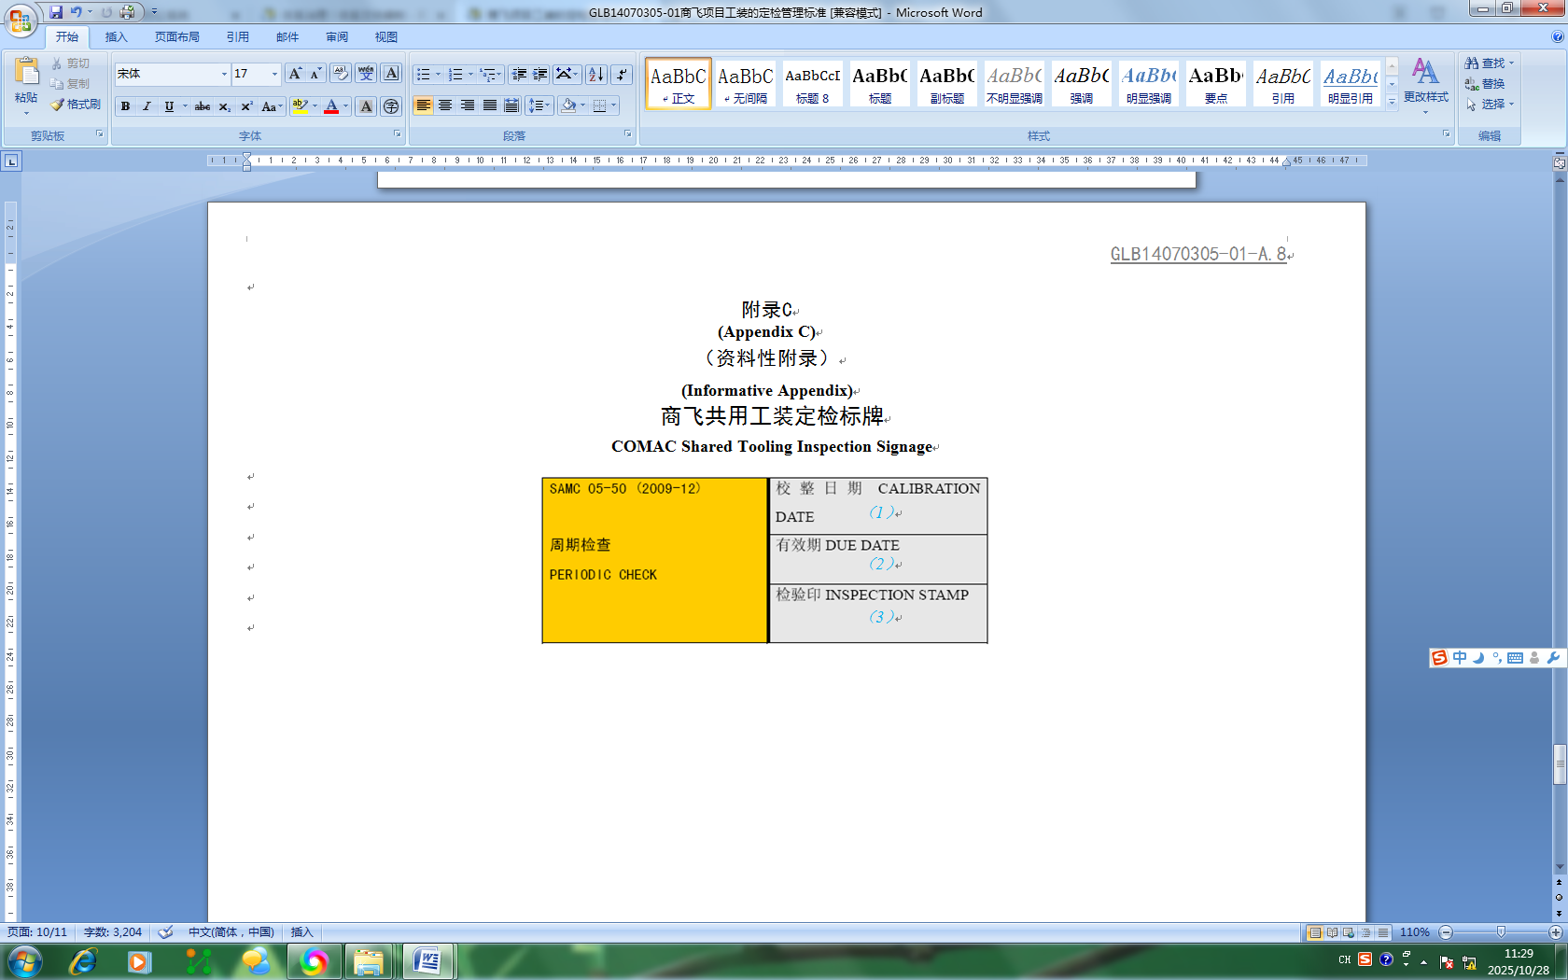

SAMC 05-50(2009-12)  周期检查  PERIODIC CHECK | 校正日期CALIBRATION DATE  （1）
有效期DUE DATE
（2）
检验印INSPECTION STAMP
（3）

